How can we create dummy data for freight costs with various modes of transportation, and use Python code to optimize the freight costs? Consider the source and destination cities, and determine which mode of transportation can provide cost savings, time efficiency, or a balance of both.

Let’s create a dummy dataset for freight cost with different modes of transportation, source city, destination city, and associated costs. We’ll then demonstrate how to optimize the freight cost using Python code.

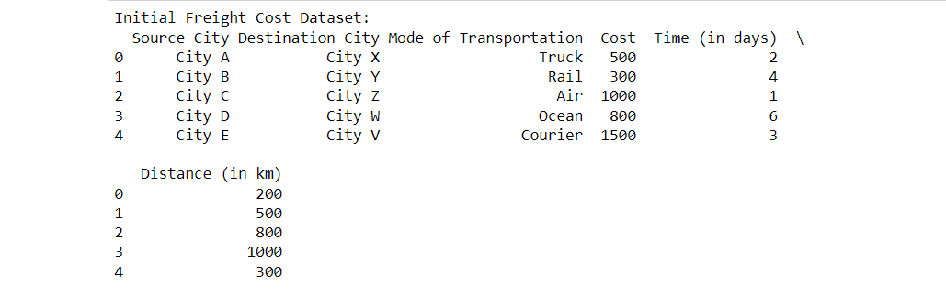

let’s update the Python code to optimize the freight cost based ondifferent criteria including cost, time, cost-time trade-off, and distance:

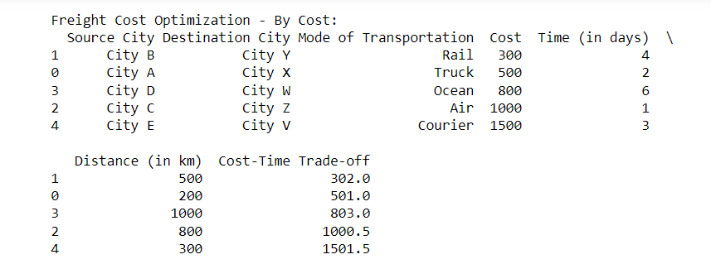

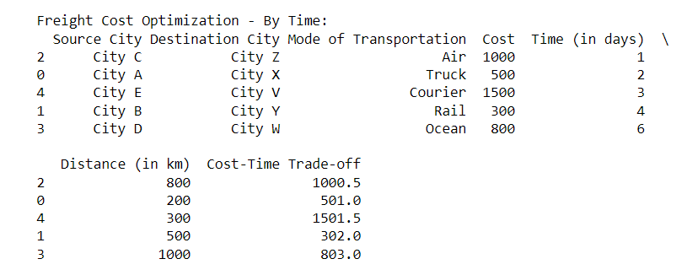

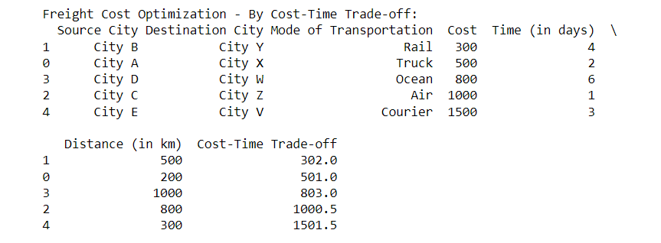

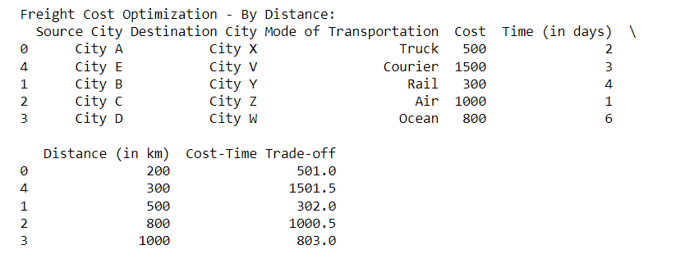

How can we optimize the scenario where two shipments are arriving at a city and another shipment is departing from the same city? Additionally, one mode of transportation is by air, while the other is by road.

To optimize the scenario where two different shipments are coming to a city and another shipment is going from that city, with one mode of transportation being air and another being road, you can consider consolidating shipments and selecting the most suitable mode of transportation. Here’s an approach to optimize such a scenario:

1.

Identify incoming shipments:

Determine the origin cities and shipment details of the two incoming shipments.

Calculate the costs and time for each shipment based on their respective modes of transportation (e.g., air, road).

Consider any volume or weight constraints that may affect the transportation mode selection.

2. Identify outgoing shipment:

Determine the destination city and shipment details for the outgoing shipment.

Calculate the cost and time for this shipment based on the available modes of transportation (e.g., air, road).

3. Consolidation and optimization:

Analyze the shipment characteristics, such as volume, weight, and delivery deadlines, to identify opportunities for consolidation.

Evaluate the overall cost and time savings that can be achieved by consolidating the shipments.

Consider the compatibility of the shipment types (e.g., hazardous goods ,temperature-sensitive items) to ensure compliance and safety during transportation.

Compare the costs and time associated with different transportation modes (e.g., air, road) for the consolidated shipment.

4. Mode selection and optimization:

Assess the trade-offs between cost and time for the consolidated shipment and the outgoing shipment.

Determine which mode of transportation (air or road) is more cost-effective and time-efficient for the given shipments.

Consider any specific requirements or constraints related to the shipments, such as delivery deadlines, transit times, or service level agreements.

Optimize the mode selection based on the consolidated cost, transit time, and other relevant factors.

By analyzing the incoming shipments, outgoing shipment, and available modes of transportation, you can optimize the logistics and select the most efficient mode (air or road) for each shipment. The optimization process may involve consolidation, cost analysis, time considerations, and trade-off evaluations. Applying data analytics and decision-making techniques can help you make informed decisions to achieve cost savings and efficient transportation.

Here’s an example that demonstrates the optimization process for consolidating shipments and selecting the optimal mode of transportation (air or road) based on cost and time considerations:

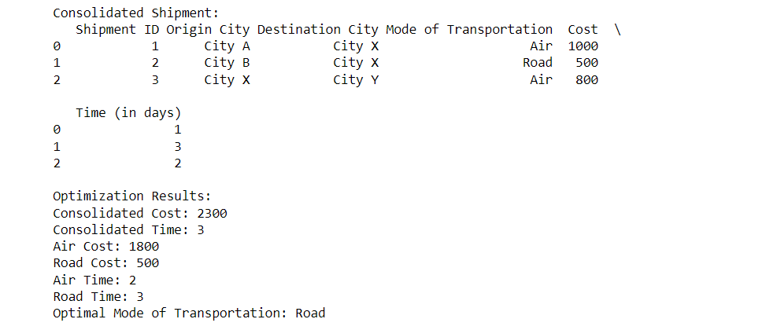

In the above example, I created dummy data for incoming shipments and an outgoing shipment. We consolidate all the shipments into a single dataframe and calculate the overall cost and time. We then compare the costs and times for air and road transportation options. Finally, based on the cost comparison, we determine the optimal mode of transportation.